Napkin Folding

Fan Fold

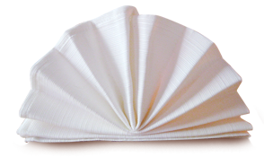

This napkin fold is easy and versatile and perfect for paper napkins. I prefer dinner sized paper napkins but you can also use regular lunch sized napkins. If you are using a square cloth napkin, then fold it in half to form a rectangle. If you are using a folded square paper napkin, unfold it so that it forms a rectangle.

Starting at a short side of the rectangle, fold the napkin edge up to create a 1 to 1 ½ inch pleat (mine tend to be 1 ½ inches). Flip the napkin over and create another 1 to1 ½” pleat. Turn the napkin again and make a 1 to 1 ½” pleat. Continue until you have only a couple of inches unpleated.

With the unpleated side of the napkin facing up, fold the napkin in half so that the pleats are now on the outside. Turn your napkin so that the pleated part is on the left and the unpleated part is towards your right and the folded edge is towards you. Take the top right corner and fold it down to form a triangle, tucking it into the back of the pleats. This will create a base for your fan to stand on. Make sure it is folded sharply. Carefully pick up the napkin and let it fan open.

You can find step by step instructions with pictures at Napkin Folding Guide.com or check out our video for this napkin fold here: http://youtu.be/YSM1LmMG1tk

Turkey Napkin Fold

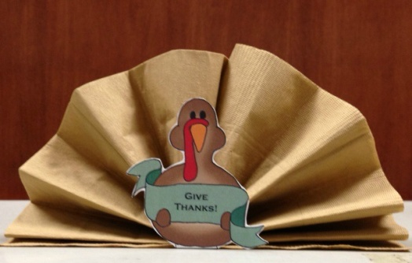

Make this cute Thanksgiving themed version of the fan fold by following the instructions to create the fan fold and printing out the free customizable turkey template found here: http://www.sparktheoccasion.com/blog/2012/11/thanksgiving-turkey-napkin-printable/

Print out the template on card stock (or print it on regular paper and then glue onto cardboard or poster board) and fold the tab under to create a stand for the turkey. Place the folded napkin on top to form the “tail”.

Christmas Tree Napkin Fold

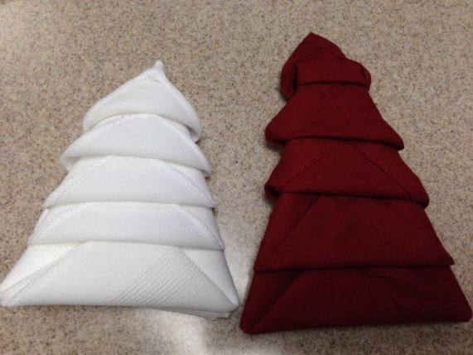

This festive napkin fold works best with a cloth napkin although if you are really careful you can make it with a paper napkin.

To make this napkin fold, start with a square napkin open in front of you. Take the top of the napkin and fold it down so the napkin forms a rectangle. Pick up the left side of the napkin and fold the napkin in half to make a square. Rotate the napkin slightly so that the square is in a diamond shape with the open ends facing toward you. Pick up the first layer of the napkin and fold towards the top point, stopping about an inch away from the top point. Pick up the next layer and fold up towards the top leaving about an inch of space between this layer and the one before. Continue to fold layers, leaving an inch between until all layers have been folded.

Keeping one hand on the layers to hold them in place, carefully turn the napkin over. Fold the left side over to meet the right. Fold the right side over to meet the left. The napkin should now resemble an ice cream cone. Carefully turn the napkin over and rotate it so the smallest folded layer is at the top. The napkin should now resemble a tree. Fold the smallest layer up. Fold the next layer up, tucking the tip under the smallest layer. Fold the remaining layers up, tucking the tip of each layer under the one above it. If desired, decorate the top of the napkin tree with a ribbon or star or ornament. I like to use a piece of chocolate for my tree topper

Find step by step photos and a video of this napkin fold here: http://www.handimania.com/diy/christmas-tree-napkin-fold.html

Two Toned Christmas Tree Napkin Fold

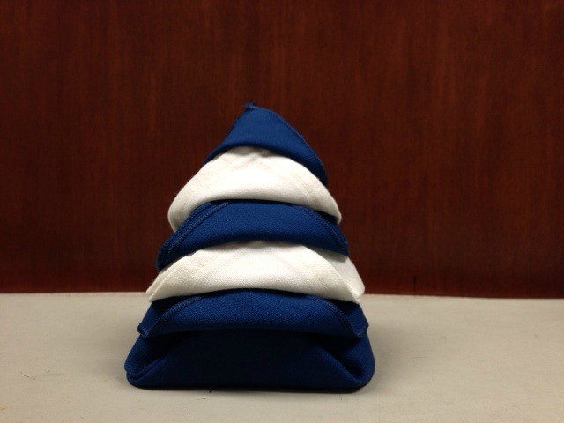

This napkin fold is made with two different colored napkins of about the same size. It is best to use cloth napkins for this napkin fold. The napkin would look stunning in red and green but I used what I had on hand.

Start with both napkins open flat in front of you with the hemmed side up. If one napkin is slightly larger than the other napkin, put the larger napkin on the bottom. Fold the top of the napkins down so the napkin is folded in half, forming a rectangle. Fold the left side to meet the right, creating a square. Turn the napkin slightly so it is in a diamond shape with the open ends pointing toward you.

Pick up the first layer of the napkin and fold towards the top point, stopping about an inch away from the top point. Pick up the next two layers (they should be the same color) and fold up towards the top leaving about an inch of space between these layers and the one before. Continue to fold layers in sets of two, leaving an inch between each set until all but the last two layers have been folded up. Fold each of the last two layers separately tucking the tip under the layer above it.

You can lay the napkin flat on the plate or you can stand it up by carefully opening the back of the tree a little to allow it to stand.

You can find step by step photos and instructions for this napkin fold here: http://betweennapsontheporch.net/christmas-tree-napkin-fold-tutorial/

Double Diamond Napkin Fold

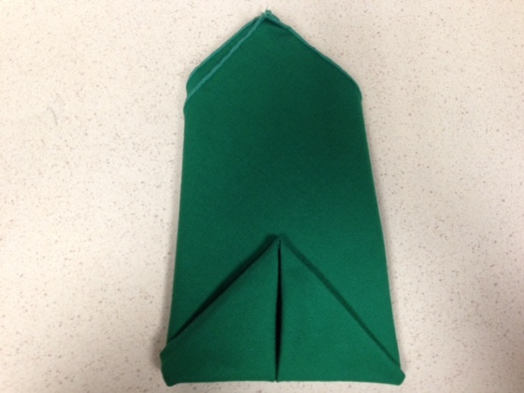

Start with the napkin open flat in front of you. Fold the top right corner down to meet the bottom left corner, creating a triangle. Turn the napkin so the folded edge is towards you and the top point of the triangle is facing away from you. Fold the left corner of the triangle up to the center point. Fold the right corner up to the center point. Your napkin should now be in a diamond shape. Carefully holding the napkin folds in place, turn it over. Fold the bottom point up about one third of the way as shown in the picture. Fold the right side behind. Fold the left side behind.

Find step by step photos of this napkin fold and others here:
http://www.seriouseats.com/2010/08/serious-entertaining-three-quick-and-easy-napkin-folds-how-to.html

Water Lily/Rose/Lotus Napkin Fold

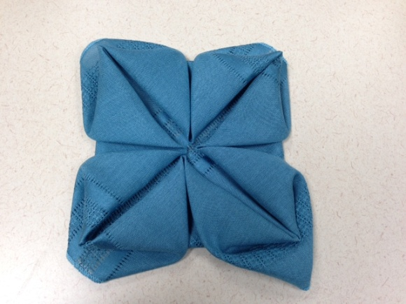

This flowery napkin fold isn’t as difficult as it looks. Start with your napkin open in a square in front of you. Fold each corner to meet the center, creating a diamond shape. Fold each new corner to the center, creating a square shape. Carefully hold the folds in place and turn the napkin over. Fold each corner to meet the center. Carefully reach under each corner and pull the loose flaps up. If necessary you can place something in the center to keep the napkin folds in place. Some people place a roll there or an orange or a small votive candle.

See step by step photos and a video of this napkin fold here:
https://www.brightsettings.com/napkin-folding-Rose.html

Pocket Napkin Fold

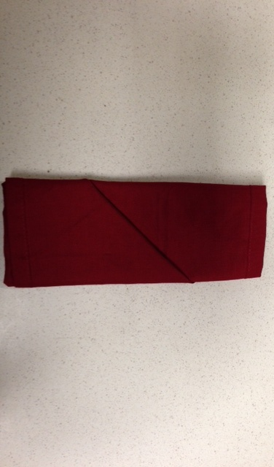

This simple napkin fold can be done with dinner size paper napkins as well as cloth napkins and it would be nice for a buffet table.

Starting with the napkin open flat in front of you, fold it in half horizontally to create a rectangle shape. Fold the left side to meet the right, creating a square. Turn the square so the open corners are at the top and facing the left. Fold the top corner down and press. Turn the napkin over so the open corners face the right. Fold the right side back about 1/3. Fold the left side back. Carefully turn the napkin over and adjust if necessary so it looks even. You can place silverware inside the pocket or a place card or small menu card.

Step by step photos for this napkin fold can be found here:

http://bumblebeelinens.com/simplePocket.php

